Non-Financial Time Series: Solar Cycle / Sunspot Number Analysis

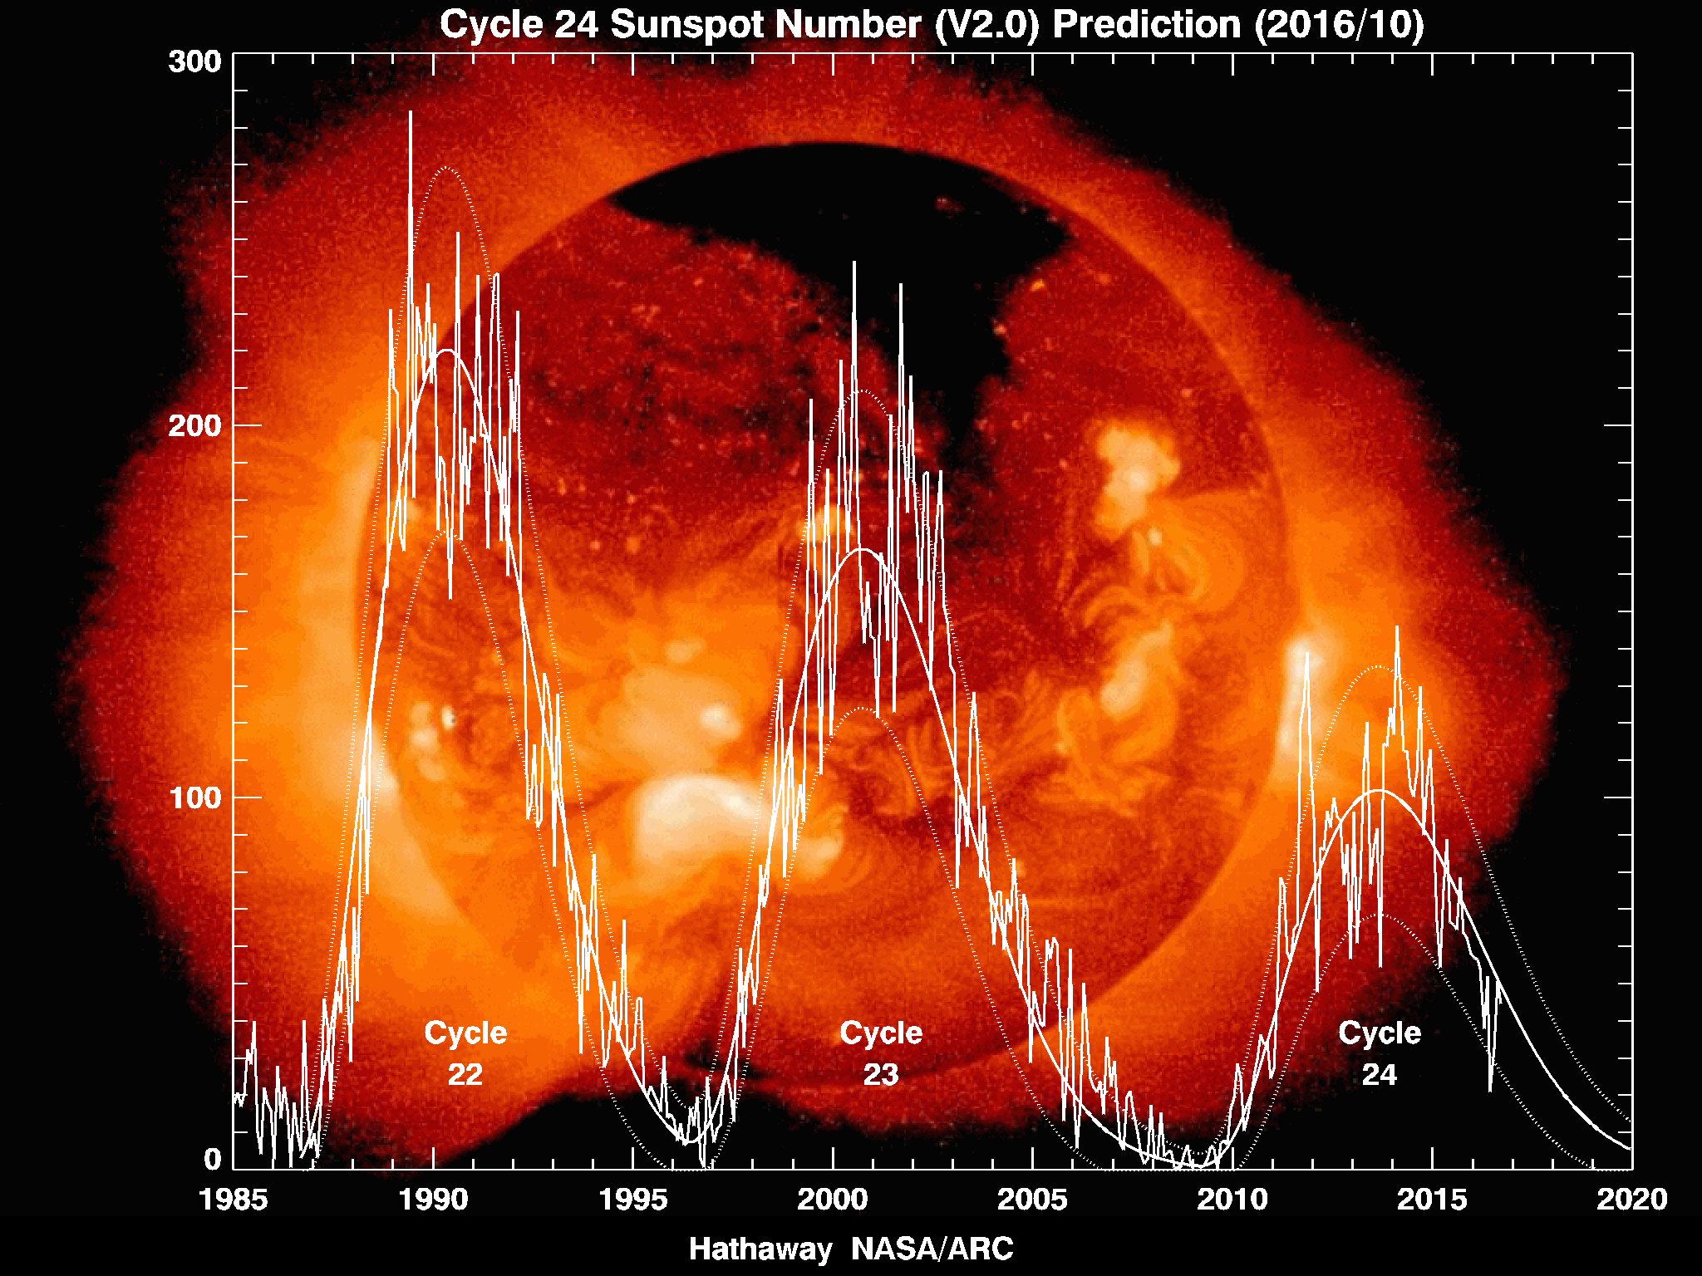

Team Members: Isabella DeAbreu, Laurenz Jakob Kluth, Navenkumar Balasubramanium, Sofia Mollon Laorca, and Vikram Bhatt.

Table of contents
Introduction 1
Exploratory Data Analysis (EDA) 1
Visualization of Time Series and Distribution 1
Statistical Analysis 1
Data Quality 2
Model Fitting 3
Model Selection 3
Forecasting 3
Conclusion 3
Appendix 3
Guidelines 8

Introduction
This project examines long-term solar activity using monthly sunspot numbers from the NOAA Space Weather Prediction Center (SWPC). The data come from the Solar Cycle Progression product and are available as the Observed Solar Cycle Indices (JSON) file or through the API that was referenced in the dataset description. From this dataset, we focus on two fields: time-tag (in YYYY-MM format) and ssn, the mean monthly sunspot number reported by the Solar Influence Data Analysis Center (S.I.D.C.). These observations span January 1749 to October 2025, making this one of the longest continuous scientific time series available. Other variables (e.g., smoothed sunspot numbers, radio flux) are excluded to maintain consistency. Sunspot numbers are an important indicator of solar magnetic activity and a key driver of space weather. Increases in solar activity can disrupt HF radio communications, degrade GPS accuracy, affect satellite orbits through enhanced atmospheric drag, and pose risks to power grids through geomagnetic currents. Because modern infrastructure depends heavily on satellites and reliable communication systems, forecasting solar variability is increasingly important. The sunspot record exhibits a well-known 11-year cycle characterized by periodic peaks and troughs, with minimal long-term trend. This strong and regular pattern is the primary reason we analyze the ssn variable, the most historically consistent measure of solar activity.

Exploratory Data Analysis (EDA)

Visualization of Time Series and Distribution
The following graph displays the monthly sunspot numbers (ssn) from 1749 to 2025, confirming the classic and well-documented patterns that were introduced above:

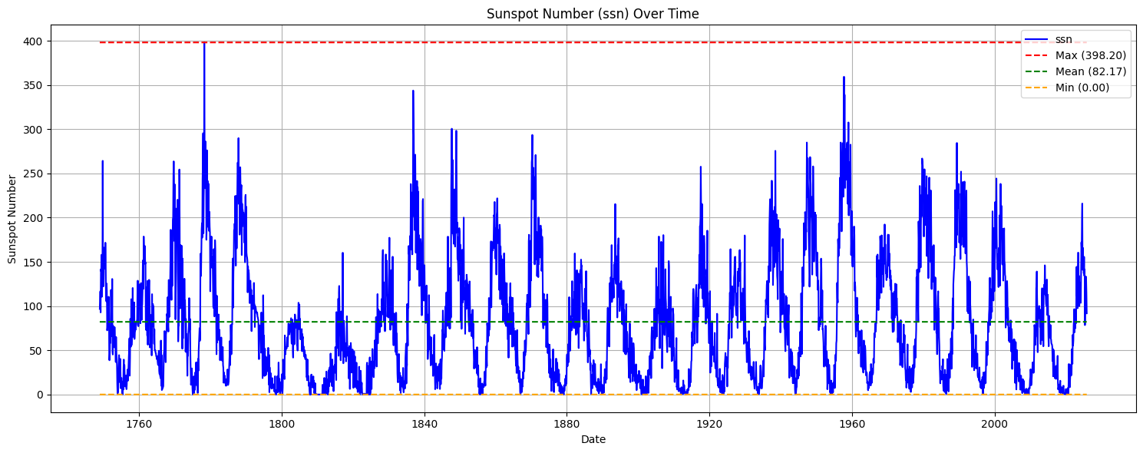
Figure 1: Sun spot numbers from 1750 to October 2025
Figure 1 shows that sunspot counts quickly increase to a peak and gradually decline toward zero before the next cycle begins, repeating consistently across the entire 275-year span. There is no evidence of a sustained long-term increase or decrease in sunspot activity, indicating that the series is likely not dominated by a trend component. Instead, the data move within a relatively stable range above 0, indicating that the series is shaped mainly by cyclical and seasonal behavior rather than by sustained growth or decline. The peaks vary per cycle from 150 to 400, reflecting natural variation in the intensity of solar activity. The cycles are asymmetric (see Appendix A), where the rise to the maximum is typically faster than the decline.

Statistical Analysis
The histogram in figure 2 shows that monthly sunspot numbers are strongly right-skewed, with many low values and a long tail of high values during active solar cycles. The fitted normal curve does not match the data well, especially near the peak and in the upper tail. The moment values support this: skewness is about 0.91, and kurtosis is slightly positive, indicating heavier-than-normal tails. The Q-Q plot in figure 3 further confirms the lack of normality. The lower and middle quantiles curve above the reference line, and the upper quantiles rise sharply, showing that the data have more very high values than a normal distribution would predict. Overall, sunspot numbers clearly do not follow a normal distribution, which reflects the natural behavior of the solar cycle and supports using time-series models rather than normal-based assumptions. To further investigate the underlying seasonal patterns, we employ seasonal plots and subseries plots in the next stage of the analysis.
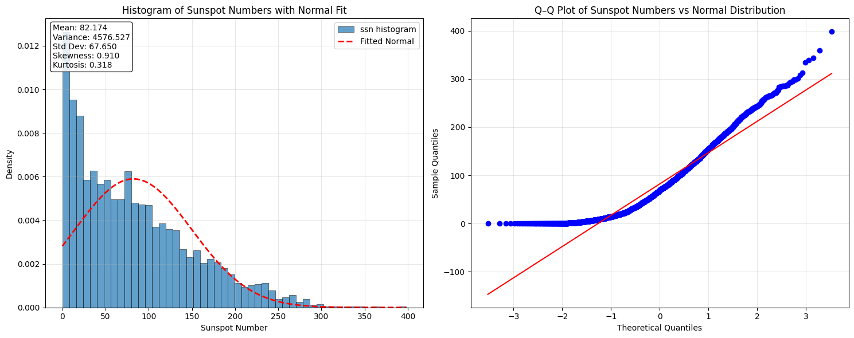
Figure 2 & 3: Histogram of Sunspot Numbers & Q-Q Plot vs. Normal Distribution
Additionally, as shown in Appendix C and D, we did an analysis of the last 4 cycles by plotting the histograms and Q-Q plots and comparing with the whole dataset. Cycle through cycle, we see similar statistical results in terms of mean values and general distribution characteristics. Each cycle maintains the characteristic patterns of solar activity with periods of high and low sunspot counts.

The skewness values for individual cycles are notably lower than the total dataset. This occurs because within a single cycle, the sunspot numbers are more spread out across the range rather than concentrated at zero. When looking at all data from 1749 onwards, the large number of zero-count periods across many cycles increases the right-skew of the total distribution. The kurtosis values for individual cycles are negative, in contrast to the positive kurtosis of the total SSN dataset. This means (a) individual cycles lack the extreme peakness near zero that characterizes the full dataset. (b) There are fewer extreme outlier values within a single 11-year cycle. (c) The distribution within each cycle is more uniform (platykurtic) rather than having heavy tails. The most recent complete cycle (2009-2019) shows notably lower solar activity compared to previous cycles. This is evident in both its lower mean sunspot number and reduced variance, indicating that Solar Cycle 24 was one of the weakest solar cycles in modern recorded history.

Furthermore, seasonal and subseries analysis was done by month of each year of each cycle, as seen in Appendix E and F. This was to understand if the summer months in the northern hemisphere (when the earth is closer to the sun) would allow the observatories to see more sun spots. It was found that the orbital position has no effect on the number of sunspots. For further information see graph of Appendix E showing the ssn over the cycle months.

The ACF and PACF analyses reveal that the deseasonalized sunspot data (using additive method because multiplicative will not work with zero values) contains strong short-term persistence, long-term dependence, and clear cyclical behavior tied to the 11-year solar cycle. The ACF shows high positive correlations at early lags that decay slowly and oscillate, indicating non-stationarity and periodic patterns, while many significant lags suggest substantial predictive power. In contrast, the PACF displays only a few significant early spikes, especially at lag 1, highlighting direct month-to-month dependence and helping identify appropriate autoregressive terms for modeling. Together, these patterns confirm that the series is non-stationary, supports ARIMA-type modeling with differencing, and remains highly predictable due to its strong autocorrelation structure even after deseasonalization. Please see Appendix G and H for further information.

Data Quality
The NOAA SWPC sunspot dataset is clean and highly consistent. All monthly observations from 1749 to 2025 are present, so there are no missing values that require interpolation or correction. A review of the distribution and time-series plots also shows no unusual spikes or anomalies. The high sunspot counts observed during solar maxima are expected features of the 11-year cycle rather than true outliers. Overall, the data quality is excellent, with a complete record and no outliers that require adjustment.

Model Fitting

Models Applied & Description
Simple Moving Average (SMA) Model smooths fluctuations across various length windows of 3, 7, 12, 15, and 24 months to show how intensity changes with length. The shorter windows (3-7 months) display mild smoothing while being very reactive to change/sudden shifts and longer windows (12-24 months) show smaller fluctuations with most noise removed.

Exponentially Weighted Moving Average (EWMA) applies exponentially decaying weights, which allows the more recent values to influence trends shown in the graph more strongly. It also responded faster to level changes and lag. In comparison to the SMA, it adapts faster to level changes, but cannot show modeling for seasonality/trend dynamics.

For the ARIMA(p,q) model we used a baseline ARIMA (2,0,2) to capture short-term autogressive behavior and moving-average components while assuming stationarity. It was mainly used as a benchmark for other models, as it did not feature seasonality or differencing.

The ARIMA(p,d,q) introduced differencing in the model ARIMA (2,1,2) to improve stationarity and display more steady residuals. Although it reduced autocorrelation, it did not erase it and still was found lacking in seasonality. Other ARIMA’s were also considered although ARIMA (2,1,2) performed the best out of all of them.

Two Seasonal ARIMAS (SARIMA) were modeled, both with an 11 year (132 month) seasonal period to reflect the solar cycle duration. Both models captured short-term autocorrelation and long-term cycle behaviors, as well as the broader dynamics of solar activity. Originally SARIMA (2,1,2) (1,1,1,11) was chosen for forecasting, but after conducting an Auto-SARIMA, SARIMA (2,1,2) (0,1,1,11) was proven to be better for modeling.

Parameter Selection
The AIC and BIC model comparison favored the seasonal ARIMA models over the nonseasonal ARIMA models (minimization across nonseasonal models), indicating that there is an importance in including seasonal differencing. However, among the nonseasonal models, ARIMA (2,1,2) performed well as a baseline, although there was still residual autocorrelation. Additionally, the Seasonal ARIMA models had a lower AIC/BIC than the original ARIMA’s supporting seasonal differencing.

Auto-ARIMA was considered and used across all ARIMA's and SARIMA's chosen. Originally SARIMA (2,1,2) (1,1,1,11) was chosen for forecasting, but after further deliberation, SARIMA (2,1,2) (0,1,1,11) was seen to have better error metrics, as well as a better AIC/BIC.

Model Diagnosis
The Seasonal ARIMA models achieved the lowest RMSE, MAE, and MAPE scores, the lowest score being for SARIMA (2,1,2) (0,1,1,11). Consistently, the AIC/BIC for the seasonal ARIMA had lower scores as well, showing a better fit.

Comparison Table:

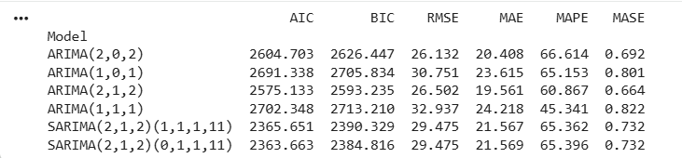

For SARIMA (2,1,2) (0,1,1,11) residuals showed no visible trend or changing variance. Variability remained stable across the entire period and showed stationarity. The ACF plot showed that autocorrelation spikes fell within the confidence interval, showing no autocorrelation. White noise was produced showing short-term and 11 year seasonal structure.

Model Selection

Comparison Criteria
Across the nonseasonal ARIMA models, the AIC and BIC decreased substantially as differencing and seasonality were introduced. ARIMA (2,1,2) produces an AIC of approximately 30777.67 and BIC of 30808.21 (reflecting stationarity). Incorporating seasonal differencing further reduced information criteria and showing the most improvement through an 11-year seasonal cycle (AIC and BIC of 30567.92 and 30610.62 respectively). The ARIMA(2,1,2) model had the lowest RMSE, MAE, and MAPE, meaning it best reproduces short-term fluctuations, however the SARIMA models did not produce the highest error metrics and fell in the middle out of all models shown. These results show that ARIMA(2,1,2) is better for short-horizon prediction accuracy, while SARIMA(11) prioritizes capturing the cycle structure. SARIMA (2,1,2) (0,1,1,11) has residuals resembling white noise, a histogram resembling a bell-shape, and no autocorrelation seen with ACF/PACF plots. While the Holt-Winters and Seasonal Naive models were considered, neither of them outperformed the SARIMA in terms of error metrics (although Holt-Winters displayed a lower AIC/BIC, it still could not be considered because of extremely high error metrics).

Final Selection
Based on criteria, forecast errors, and residuals, the SARIMA model featuring the 11-year season period with 132 months was selected as our final model (SARIMA (2,1,2)(0,1,1,11)). This was achieved through the lowest AIC and BIC values, as well as the removal of most of seasonal autocorrelation which produced residuals resembling white noise. The 11-year SARIMA incorporates the true periodic structure of solar cycles without overfitting, with no meaningful remaining autocorrelation. No unnecessary parameters were added for the short-term fluctuations, which makes the 11 year SARIMA least likely for overfitting and best for long-term forecasting.

Compared to nonseasonal ARIMA’s or the Holt-Winters model, SARIMA leads to helpful forecasts and implies meaningful periodic structure in the solar cycle/sunspot numbers, which can improve interpretability. The SARIMA with an 11-year cycle provides the most consistent and accurate representation of the monthly sunspot index.

Forecasting
Generating Forecast

Accuracy Assessment

Interpretation

Conclusion

Appendix
Appendix A - Shorter time-frame view of the number of sun-spots from two observatories with smoothed values (taken from the data, not our own)
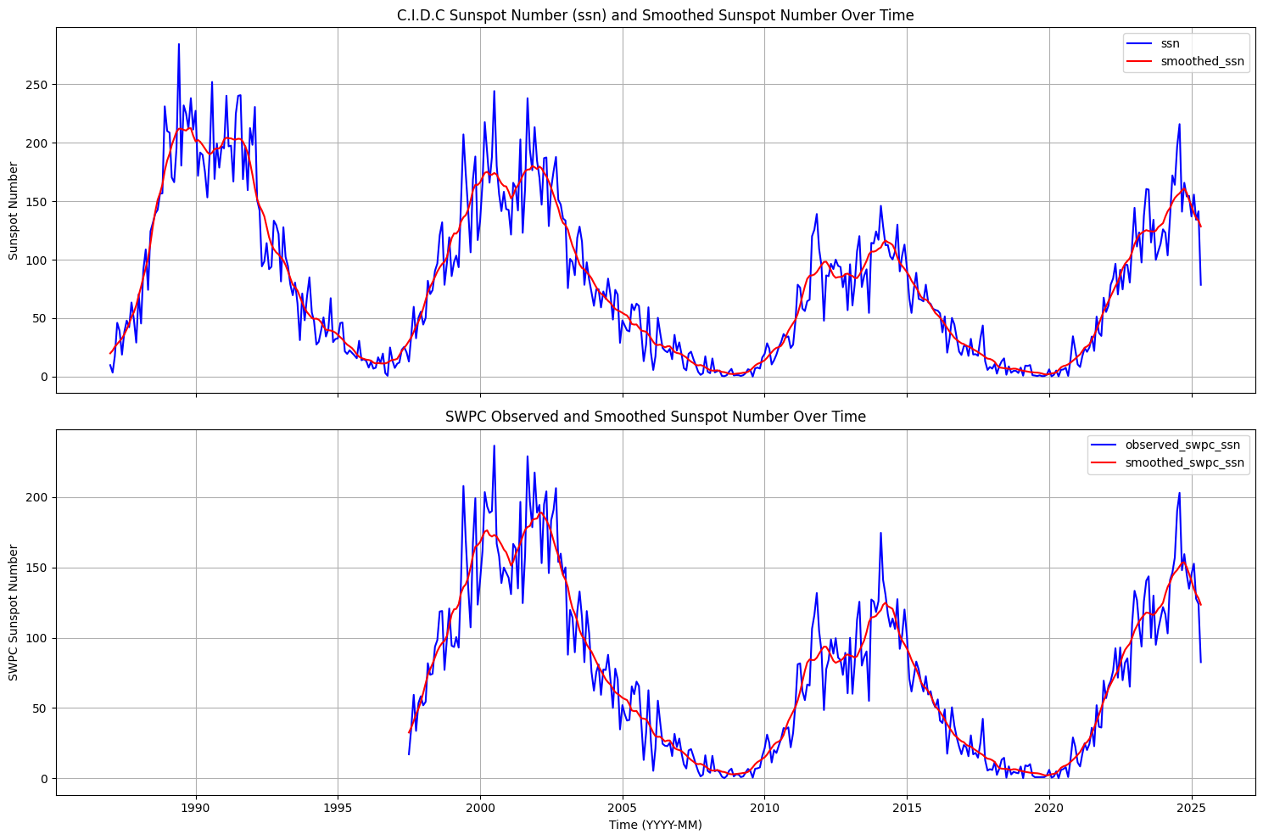

Appendix B - ssn from one observatory starting from the mid 1700s
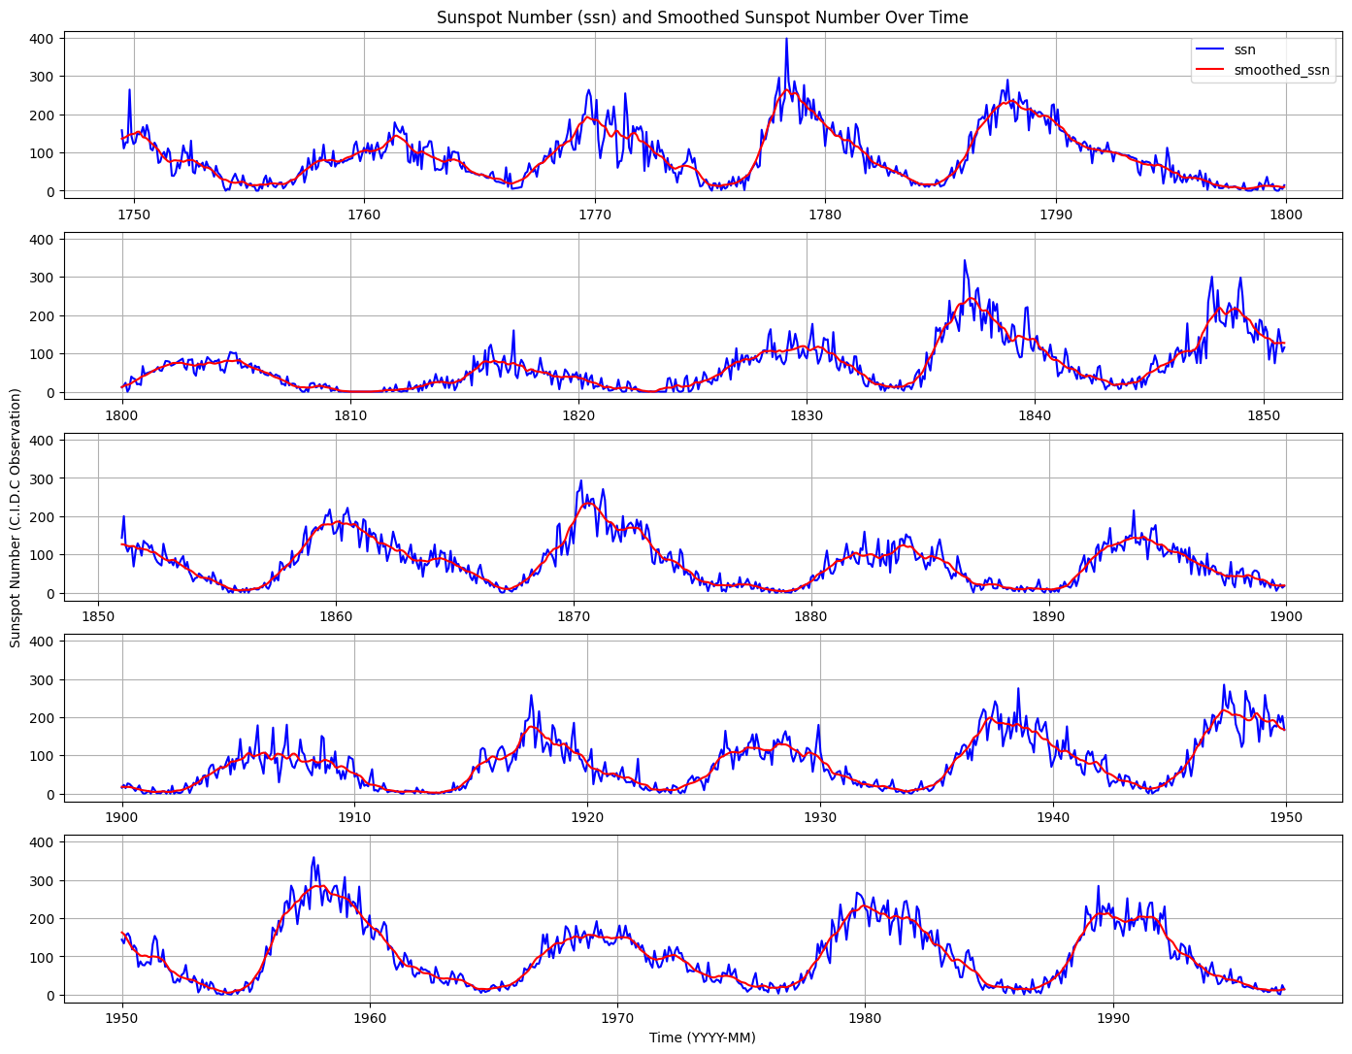
Appendix C - ssn per cycle between 1987-2025 (4 cycles) and the subsequent box-plots for each year of cycle
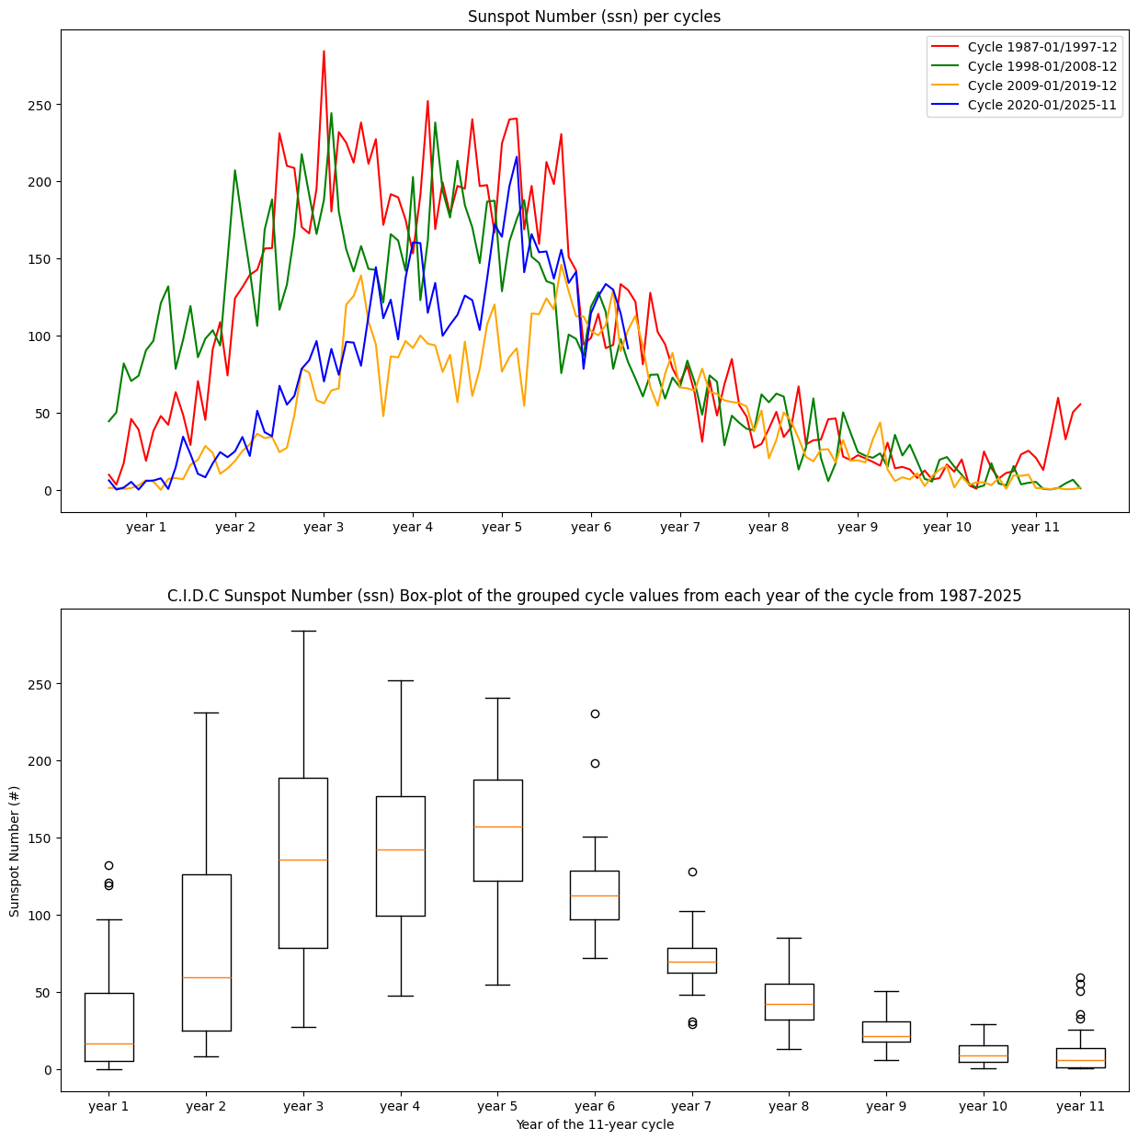

Appendix D - statistical analysis of the most recent cycles and the total ssn dataset
 | Mean | Variance | Standard Dev. | Skewness | Kurtosis
Cycle 1987-1997 | 98.415909 | 6180.543638 | 78.616434 | 0.504937 | -1.153346
Cycle 1998-2008 | 89.400000 | 4319.430076 | 65.722371 | 0.334712 | -1.019950
Cycle 2009-2019 | 49.466667 | 1708.607125 | 41.335301 | 0.465434 | -1.061620
Cycle 2020-2025 | 86.911268 | 3267.147586 | 57.158968 | -0.031702 | -1.069919
Total SSN (All Data) | 82.174090 | 4576.527080 | 67.650034 | 0.909963 | 0.318297

Appendix E - Monthly seasonal plot breakdown
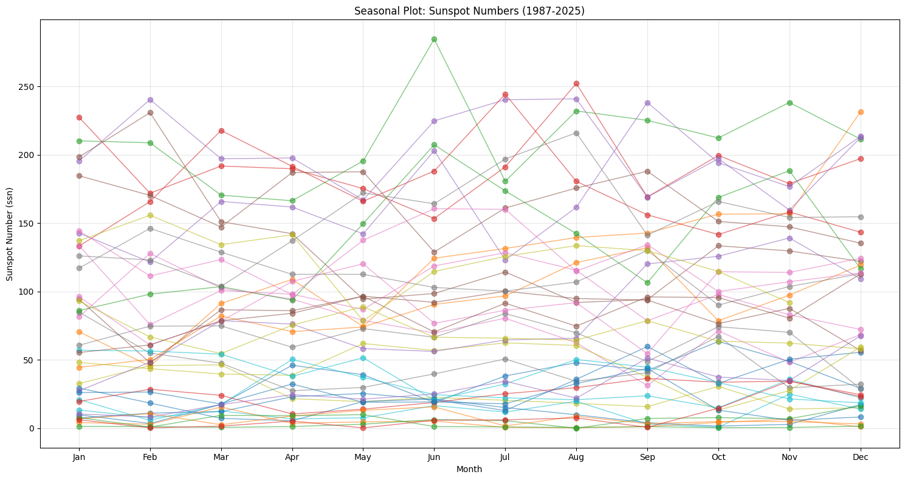

Appendix F - Seasonal subseries plot for 4 cycles.
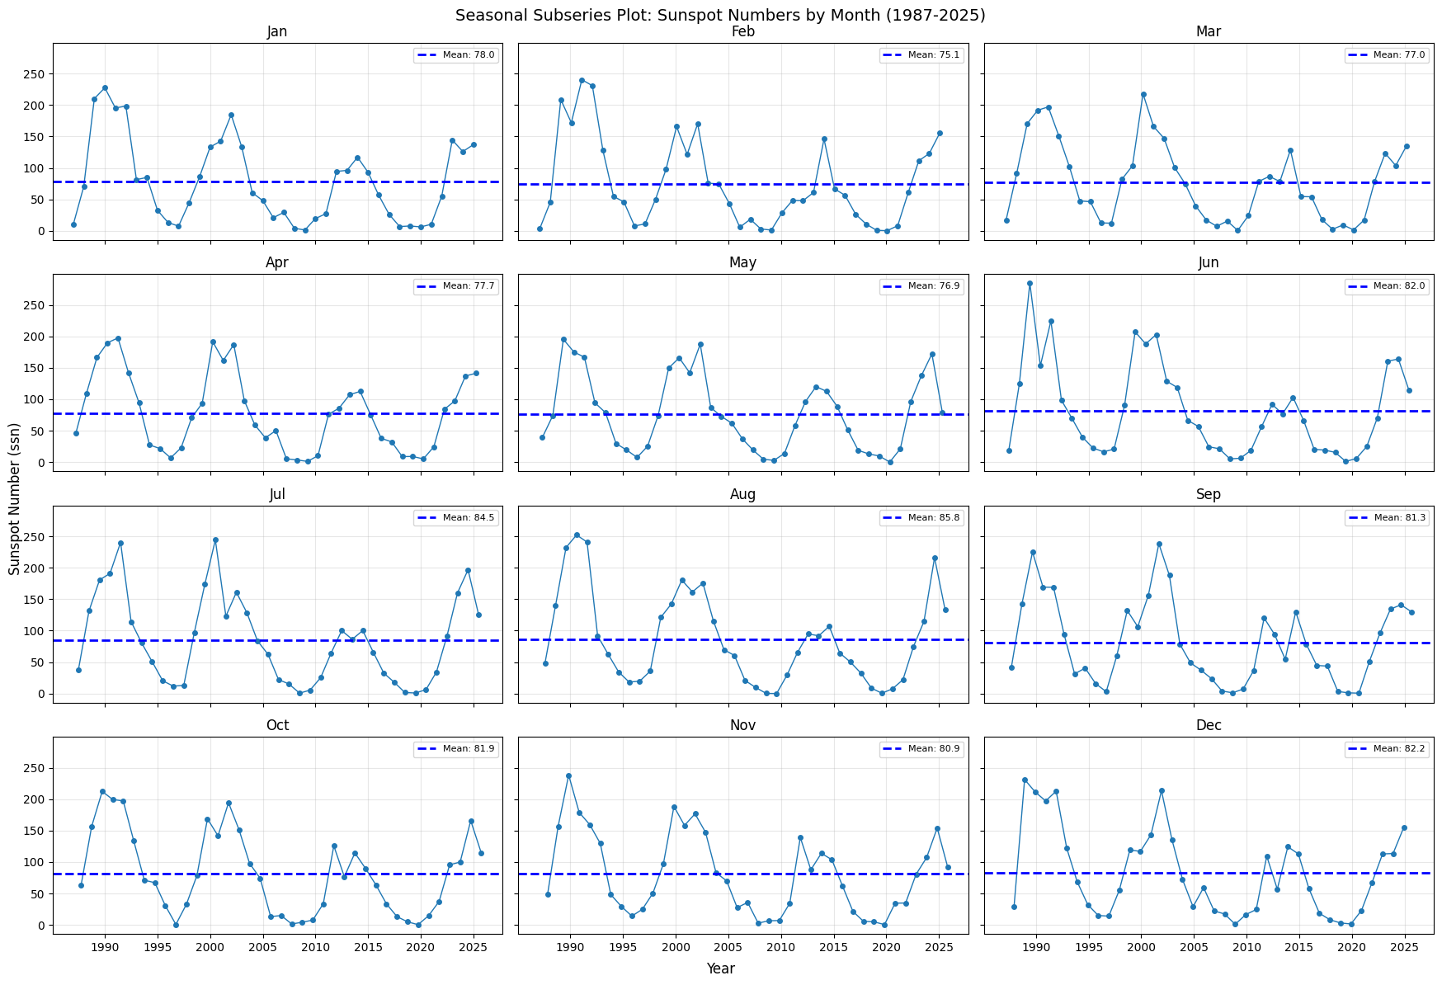

Appendix G - ACF and PACF plot of the initial ssn time series
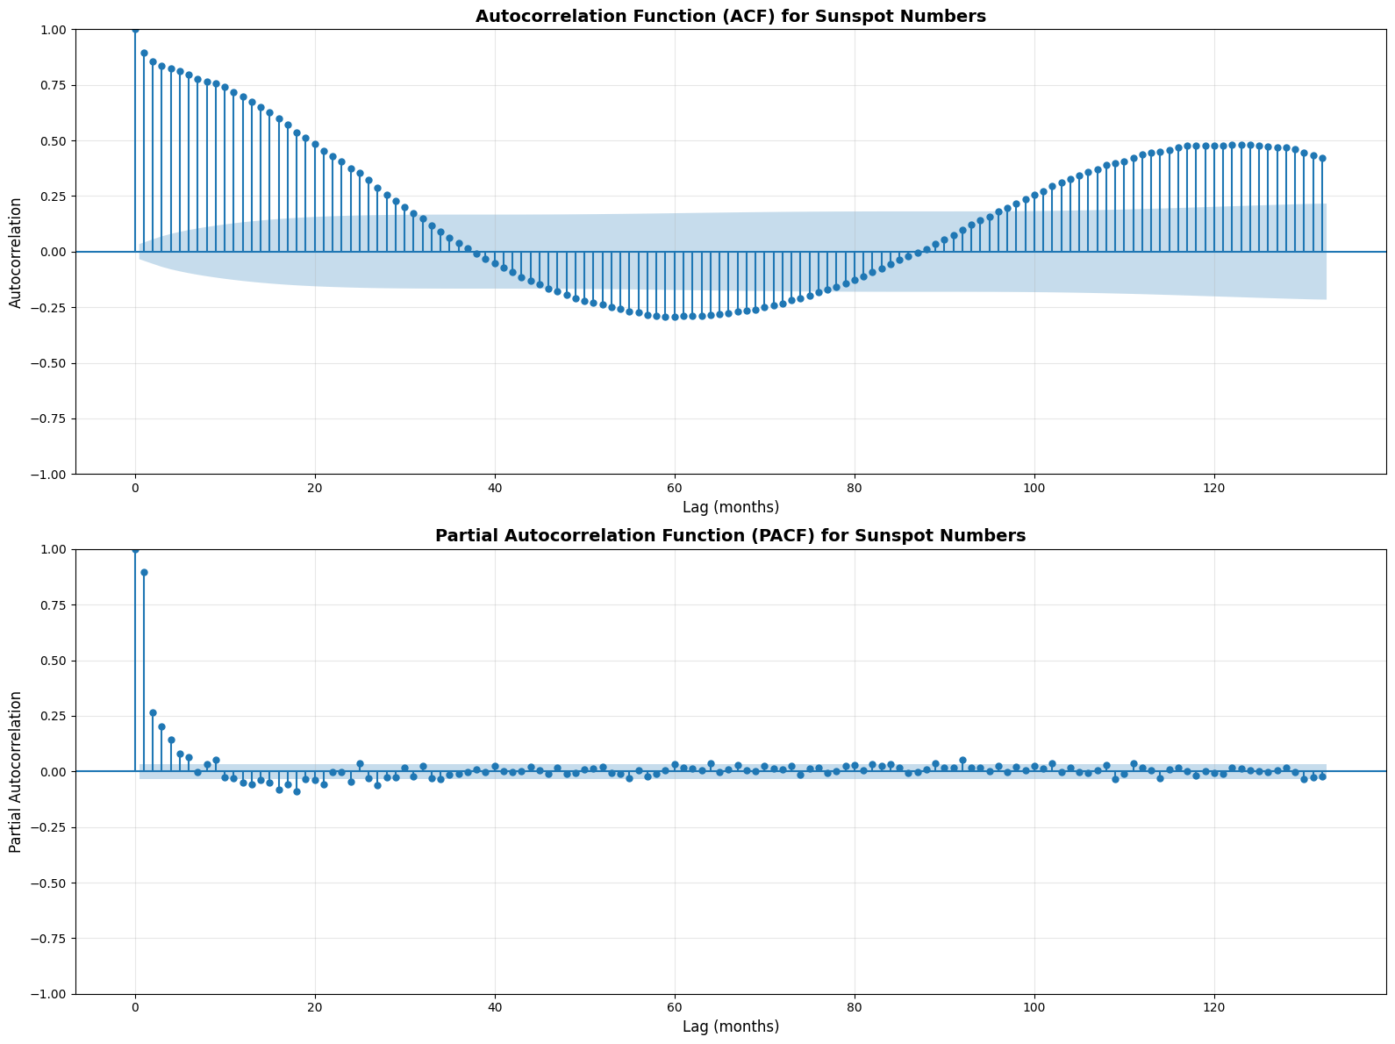

Appendix H - ACF and PACF values on ssn time series
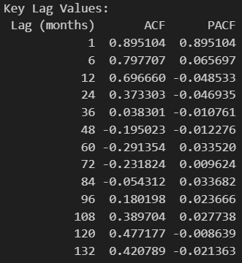

Guidelines
Task 2: Exploratory Data Analysis (EDA)
2.1 Visualization
- Plot time series and identify patterns
- Create seasonal plots and subseries plots
2.2 Pattern Identification
- Check for seasonality (daily, weekly, monthly, annual)
- Identify trends (upward, downward, changing)
2.3 Statistical Analysis
- Summary statistics (mean, median, std, etc.)
- ACF and PACF plots
2.4 Data Quality
- Handle missing values
- Identify and treat outliers
Task 3: Model Fitting
3.1 Models to Apply
- Simple Moving Average (SMA)
- Exponentially Weighted Moving Average (EWMA)
- ARMA(p,q)
- ARIMA(p,d,q)
- Seasonal ARIMA (SARIMA)
3.2 Parameter Selection
- Use AIC/BIC for model comparison
- Use ACF/PACF patterns to guide choices
- Consider auto.arima() but justify your selection
3.3 Model Diagnostics
- Compare AIC, BIC, RMSE, MAE, MAPE
- Residual analysis (ACF/PACF of residuals, normality checks)
- Create comparison table
Task 4: Model Selection
4.1 Comparison Criteria
- Information criteria (AIC, BIC)
- Error metrics (RMSE, MAE, MAPE, MASE)
- Residual diagnostics
4.2 Final Selection
- Justify your best model choice
- Consider fit quality and interpretability
- Address overfitting concerns
Task 5: Forecasting
5.1 Generate Forecasts
- In-sample forecasts (fitted values)
- Out-of-sample forecasts (train/test split)
5.2 Assess Accuracy
- Calculate RMSE, MAE, MAPE, MASE
- Visualize forecasts with actual values
- Include prediction intervals if available
5.3 Interpretation
- Discuss practical implications
- Provide insights and limitations

Evaluation Criteria
- Dataset Selection (10%): Appropriateness, quality, description
- EDA (20%): Thoroughness, visualizations, pattern identification
- Modeling (30%): Model selection, parameter estimation, comparison
- Diagnostics (20%): Diagnostic checks, model comparison, justification
- Forecasting (10%): Forecast generation, accuracy, interpretation
- Presentation & Documentation (10%): Notebook quality, presentation clarity

